APQB 3.9 Automatic Stabilizers

- Which of the following statements best describes the concept of an automatic stabilizer?
- It is nondiscretionary fiscal policy that mitigates business cycles by increasing aggregate demand during recessions and decreasing aggregate demand during expansions.
- It is discretionary fiscal policy that increases government spending during recessions and decreases government spending during expansions.
- It is a measure of the effect that a change in government spending and investment has on the gross domestic product.
- It is a description of how total income is always equal to total expenditures as a measure of gross domestic product.
- It is the process whereby surpluses lead to falling prices and shortages lead to rising prices to stabilize market equilibrium.
- Which of the following is an example of an automatic stabilizer?
- Discretionary fiscal policy
- Progressive income taxes
- consumption by high income households
- Increased penalties for criminal activity
- Cyclical unemployment
- Recessions will most likely be less severe if tax revenues and transfer payments automatically change in which of the following ways?
- Tax revenues increase, and transfer payments increase.
- Tax revenues decrease, and transfer payments decrease.
- Tax revenues increase, and transfer payments decrease.
- Tax revenues decrease, and transfer payments increase.
- Tax revenues do not change, and transfer payments decrease.
- Automatic stabilizers can do which of the following?
- Offset the destabilizing influence of changes in tax revenues
- Aid the economy to move away from the full-employment output level
- Allow policymakers to formulate a set of rules flexible and comprehensive enough to eliminate discretionary actions
- Cause tax revenues to decrease when gross domestic product (GDP) decreases and to increase when GDP increases
- Allow policymakers to prescribe public works programs during inflationary periods because expenditures for unemployment and welfare have correspondingly decreased
- A major advantage of automatic stabilizers in fiscal policy is that they
- reduce the public debt
- increase the possibility of a balanced budget
- stabilize the unemployment rate
- go into effect without passage of new legislation
- automatically reduce the inflation rate
- Challenge question: Which of the following will most likely occur if a government adopts an annually balanced budget rule that requires the government to eliminate any deficits or surpluses?
- Unemployment will be eliminated and prices will be stable.
- The national debt will increase.
- Business cycles will become more stable.
- The automatic stabilizing effect of fiscal policy will be eliminated.
- The government will be forced to spend less when there are surpluses.
- It is the process whereby surpluses lead to falling prices and shortages lead to rising prices to stabilize market equilibrium.
- All the following are examples of automatic stabilizers EXCEPT:
- unemployment insurance benefits
- personal income taxes
- welfare benefits
- corporate income taxes
- tariffs

- Assume that the economy of Meekland is in a long-run equilibrium with a balanced government budget.
- Using a correctly labeled graph of aggregate supply and aggregate demand, show each of the following.
- Long-run aggregate supply
- The output level, labeled YE, and the price level, labeled PLE
- Assume consumer confidence falls. Show on your graph in part (a) the short-run impact of the change in consumer confidence and label the new equilibrium price level and output Y1 and PL1, respectively.
- Using a correctly labeled PPC, show the effect of the fall in consumer confidence. Label the initial long-run equilibrium point A and the new short-run equilibrium point B.
- If the government does not pursue any discretionary policy change, how does the fall in consumer confidence affect government transfer payments in Meekland? Explain.
- Show the effect of the change in government transfer payments you identified in part (d) on the graph from part a)
- In the absence of any changes in fiscal and monetary policies, in the long run will the short-run aggregate supply curve shift to the left, shift to the right, or remain unchanged as a result of the fall in consumer confidence? Explain.

1 | A | 6 | D
2 | B | 7 | E
3 | D | 8
4 | D
5 | D
8 A,b, e
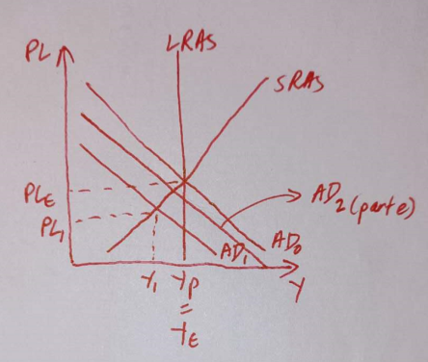
c.
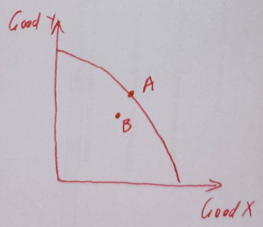
d. real income falls so there are more people who will require gov assistance, so gov transfer payments increase.
f. shift to the right when the wages fall in the long run

